**B.M.S COLLEGE OF ENGINEERING**

(Autonomous College under VTU)

**Department of Electronics and Communication Engineering**

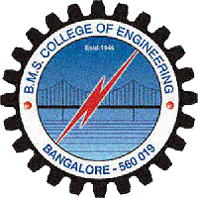

**CERTIFICATE**

This is to certify that the project entitled **“PRECISION AGRICULTURE”** is a bonafide work carried out by **Hemantha Gowda C V** (USN:1BM11EC406), **Kaveen Kumar M K** (USN:1BM11EC408), **Nikhil D G** (USN:1BM11EC415) and **Prathap J** (USN:1BM11EC417) in partial fulfillment for the award of Bachelor of Engineering degree by VTU Belgaum, during the academic year 2013-2014.

**Harish V Mekali** **Dr.D .Seshachalam** **Dr.K.Mallikharjuna Babu**

Assistant Prof., ECE, BMSCE HOD, ECE, BMSCE Principal, BMSCE

**External Examination:**  **Signature with date:**

1.

2.